**Group Dynamics: it’s characteristics, stages, types, factors ,team building and other Details!**

People may underestimate the importance of society and group memberships on their lives. Whilst people sometimes undertake solo journeys yet by and large much of our experiences of life involves being engaged with others and groups.

Within an organization we do find number of groups. Individuals joining group (s) is a reality – may be formal or informal groups. People work in groups quite frequently and in many different areas of their life e.g. at work, school/college, sport, hobbies. The managers need to understand Group Dynamics that can enable managers to adopt the right approach of interacting with them.

**What is Group Dynamics?**

Group dynamics deals with the attitudes and behavioral patterns of a group. Group dynamics concern how groups are formed, what is their structure and which processes are followed in their functioning. Thus, it is concerned with the interactions and forces operating between groups.

Group dynamics is relevant to groups of all kinds – both formal and informal. If the UPA government has set up Group of Ministers for every governance issue, the Supreme Court of India has 27 Group of Judges committees overseeing all manner of non-judicial work in the apex court. In an organizational setting, the term groups are a very common and the study of groups and group dynamics is an important area of study.

**What is A Group?**

Every organization is a group unto itself. A group refers to two or more people who share a common meaning and evaluation of themselves and come together to achieve common goals. In other words, a group is a collection of people who interact with one another; accept rights and obligations as members and who share a common identity.

**Characteristics of a Group:**

**Regardless of the size or the purpose, every group has similar characteristics:**

(a) 2 or more persons (if it is one person, it is not a group)

(b) Formal social structure (the rules of the game are defined)

(c) Common fate (they will swim together)

(d) Common goals (the destiny is the same and emotionally connected)

(e) Face-to-face interaction (they will talk with each other)

(f) Interdependence (each one is complimentary to the other)

(g) Self-definition as group members (what one is who belongs to the group)

(h) Recognition by others (yes, you belong to the group).

**Process/Stages of Group Development/Evolution:**

Group Development is a dynamic process. How do groups evolve? There is a process of five stages through which groups pass through. The process includes the five stages: forming, storming, forming, performing, and adjourning.

**Forming:**

The first stage in the life of a group is concerned with forming a group. This stage is characterized by members seeking either a work assignment (in a formal group) or other benefit, like status, affiliation, power, etc. (in an informal group). Members at this stage either engage in busy type of activity or show apathy.

**Storming:**

The next stage in this group is marked by the formation of dyads and triads. Members seek out familiar or similar individuals and begin a deeper sharing of self. Continued attention to the subgroup creates a differentiation in the group and tensions across the dyads / triads may appear. Pairing is a common phenomenon. There will be conflict about controlling the group.

**Norming:**

The third stage of group development is marked by a more serious concern about task performance. The dyads/triads begin to open up and seek out other members in the group. Efforts are made to establish various norms for task performance.

Members begin to take greater responsibility for their own group and relationship while the authority figure becomes relaxed. Once this stage is complete, a clear picture will emerge about hierarchy of leadership. The norming stage is over with the solidification of the group structure and a sense of group identity and camaraderie.

**Performing:**

This is a stage of a fully functional group where members see themselves as a group and get involved in the task. Each person makes a contribution and the authority figure is also seen as a part of the group. Group norms are followed and collective pressure is exerted to ensure the Process of Group effectiveness of the group.

The group may redefine its goals Development in the light of information from the outside environment and show an autonomous will to pursue those goals. The long-term viability of the group is established and nurtured.**[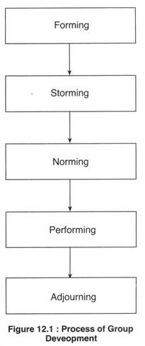](https://www.yourarticlelibrary.com/wp-content/uploads/2013/08/clip_image00231.jpg)**

**Adjourning:**

In the case of temporary groups, like project team, task force, or any other such group, which have a limited task at hand, also have a fifth stage, This is known as adjourning.

The group decides to disband. Some members may feel happy over the performance, and some may be unhappy over the stoppage of meeting with group members. Adjourning may also be referred to as mourning, i.e. mourning the adjournment of the group.

The readers must note that the four stages of group development mentioned above for permanent groups are merely suggestive. In reality, several stages may go on simultaneously.

**Types of Groups:**

One way to classify the groups is by way of formality – formal and informal. While formal groups are established by an organization to achieve its goals, informal groups merge spontaneously. Formal groups may take the form of command groups, task groups, and functional groups.

**1. Command Groups:**

Command groups are specified by the organizational chart and often consist of a supervisor and the subordinates that report to that supervisor. An example of a command group is a market research firm CEO and the research associates under him.

**2. Task Groups:**

Task groups consist of people who work together to achieve a common task. Members are brought together to accomplish a narrow range of goals within a specified time period. Task groups are also commonly referred to as task forces. The organization appoints members and assigns the goals and tasks to be accomplished.

Examples of assigned tasks are the development of a new product, the improvement of a production process, or designing the syllabus under semester system.

Other common task groups are ad hoc committees, project groups, and standing committees. Ad hoc committees are temporary groups created to resolve a specific complaint or develop a process are normally disbanded after the group completes the assigned task.

**3. Functional Groups:**

A functional group is created by the organization to accomplish specific goals within an unspecified time frame. Functional groups remain in existence after achievement of current goals and objectives. Examples of functional groups would be a marketing department, a customer service department, or an accounting department.

In contrast to formal groups, informal groups are formed naturally and in response to the common interests and shared values of individuals. They are created for purposes other than the accomplishment of organizational goals and do not have a specified time frame. Informal groups are not appointed by the organization and members can invite others to join from time to time.

Informal groups can have a strong influence in organizations that can either be positive or negative. For example, employees who form an informal group can either discuss how to improve a production process or how to create shortcuts that jeopardize quality. Informal groups can take the form of interest groups, friendship groups, or reference groups.

**i. Interest Group:**

Interest groups usually continue over time and may last longer than general informal groups. Members of interest groups may not be part of the same organizational department but they are bound together by some other common interest.

The goals and objectives of group interests are specific to each group and may not be related to organizational goals and objectives. An example of an interest group would be students who come together to form a study group for a specific class.

**ii. Friendship Groups**:

Friendship groups are formed by members who enjoy similar social activities, political beliefs, religious values, or other common bonds. Members enjoy each other’s company and often meet after work to participate in these activities. For example, a group of employees who form a friendship group may have a yoga group, a Rajasthani association in Delhi, or a kitty party lunch once a month.

**iii. Reference Groups**:

A reference group is a type of group that people use to evaluate themselves. The main objectives of reference groups are to seek social validation and social comparison. Social validation allows individuals to justify their attitudes and values while social comparison helps individuals evaluate their own actions by comparing themselves to others. Reference groups have a strong influence on members’ behavior. Such groups are formed voluntarily. Family, friends, and religious affiliations are strong reference groups for most individuals.

**[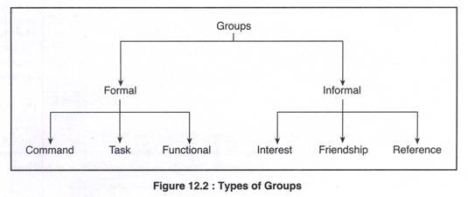](https://www.yourarticlelibrary.com/wp-content/uploads/2013/08/clip_image00423.jpg)**

**Factors Affecting Group Behaviour:**

The success or failure of a group depends upon so many factors. Group member resources, structure (group size, group roles, group norms, and group cohesiveness), group processes (the communication, group decision making processes, power dynamics, conflicting interactions, etc.) and group tasks (complexity and interdependence).

**1. Group Member Resources:**

The members’ knowledge, abilities, skills; and personality characteristics (sociability, self- reliance, and independence) are the resources the group members bring in with them. The success depends upon these resources as useful to the task.

**2. Group Structure:**

**Group Size:**

Group size can vary from 2 people to a very large number of people. Small groups of two to ten are thought to be more effective because each member has ample opportunity to take part and engage actively in the group. Large groups may waste time by deciding on processes and trying to decide who should participate next.

Evidence supports the notion that as the size of the group increases, satisfaction increases up to a certain point. Increasing the size of a group beyond 10-12 members’ results in decreased satisfaction. It is increasingly difficult for members of large groups to identify with one another and experience cohesion.

**Group Roles**:

In formal groups, roles are always predetermined and assigned to members. Each role shall have specific responsibilities and duties. There are, however, emergent roles that develop naturally to meet the needs of the groups.

These emergent roles will often substitute the assigned roles as individuals begin to express themselves and become more assertive. Group roles can then be classified into work roles, maintenance roles, and blocking roles.

Work roles are task-oriented activities that involve accomplishing the group’s goals. They involve a variety of specific roles such as initiator, informer, clarifier, summarizer, and reality tester.

Maintenance roles are social-emotional activities that help members maintain their involvement in the group and raise their personal commitment to the group. The maintenance roles are harmonizer, gatekeeper, consensus tester, encourager, and compromiser.

**[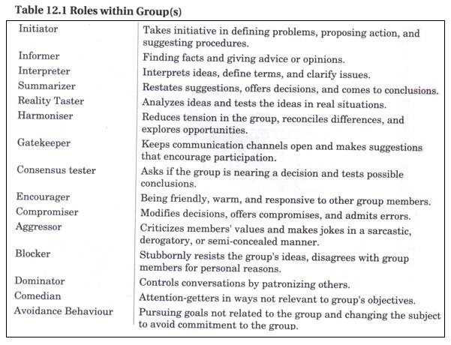](https://www.yourarticlelibrary.com/wp-content/uploads/2013/08/clip_image00618.jpg)**

Blocking roles are activities that disrupt the group. Blockers will stubbornly resist the group’s ideas, disagree with group members for personal reasons, and will have hidden agendas. They may take the form of dominating discussions, verbally attacking other group members, and distracting the group with trivial information or unnecessary humour.

Often times the blocking behaviour may not be intended as negative. Sometimes a member may share a joke in order to break the tension, or may question a decision in order to force group members to rethink the issue. The blocking roles are aggressor, blocker, dominator, comedian, and avoidance behaviour.

Role conflicts arise when there is ambiguity (confusion about delegation and no specific job descriptions) between the sent role and the received role which leads to frustration and dissatisfaction, ultimately leading to turnover; inconsistency between the perceived role and role behaviour (conflict between work roles and family roles); and conflicting demands from different sources while performing the task.

**Group Norms**:

Norms define the acceptable standard or boundaries of acceptable and unacceptable behaviour, shared by group members. They are typically created in order to facilitate group survival, make behaviour more predictable, avoid embarrassing situations, and express the values of the group.

Each group will create its own norms that might determine from the work performance to dress to making comments in a meeting. Groups exert pressure on members to force them to conform to the group’s standards and at times not to perform at higher levels. The norms often reflect the level of commitment, motivation, and performance of the group.

The majority of the group must agree that the norms are appropriate in order for the behaviour to be accepted. There must also be a shared understanding that the group supports the norms. It should be noted, however, that members might violate group norms from time to time.

If the majority of members do not adhere to the norms, then they will eventually change and will no longer serve as a standard for evaluating behaviour. Group members who do not conform to the norms will be punished by being excluded, ignored, or asked to leave the group.

**Group Cohesiveness**:

Cohesiveness refers to the bonding of group members or unity, feelings of attraction for each other and desire to remain part of the group. Many factors influence the amount of group cohesiveness – agreement on group goals, frequency of interaction, personal attractiveness, inter-group competition, favourable evaluation, etc.

The more difficult it is to obtain group membership the more cohesive the group will be. Groups also tend to become cohesive when they are in intense competition with other groups or face a serious external threat to survival. Smaller groups and those who spend considerable time together also tend to be more cohesive.

Cohesiveness in work groups has many positive effects, including worker satisfaction, low turnover and absenteeism, and higher productivity. However, highly cohesive groups may be detrimental to organizational performance if their goals are misaligned with organizational goals.

Highly cohesive groups may also be more vulnerable to groupthink. Groupthink occurs when members of a group exert pressure on each other to come to a consensus in decision making. Groupthink results in careless judgments, unrealistic appraisals of alternative courses of action, and a lack of reality testing.

Evidence suggests that groups typically outperform individuals when the tasks involved require a variety of skills, experience, and decision making. Groups are often more flexible and can quickly assemble, achieve goals, and disband or move on to another set of objectives.

Many organizations have found that groups have many motivational aspects as well. Group members are more likely to participate in decision-making and problem-solving activities leading to empowerment and increased productivity. Groups complete most of the work in an organization; thus, the effectiveness of the organization is limited by the effectiveness of its groups.

**[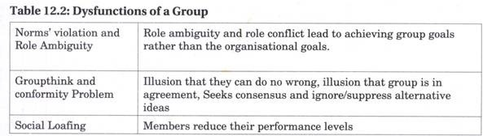](https://www.yourarticlelibrary.com/wp-content/uploads/2013/08/clip_image00812.jpg)**

**3. Group Processes:**

Decision-making by a group is superior, because group generates more information and knowledge, generates diverse alternatives, increases acceptance of a solution, and increases legitimacy. But it is also true, that decision making is like ‘munde munde matirbhinna’.

Decisions take longer time, minority is dominated, pressure is applied to conform to group decisions, and none is responsible for the decisions. Group processes also include communication, conflict management, and leadership that we shall discuss in details in the chapters to follow hereafter.

**Turning Groups into Effective Teams:**

All teams are groups but not all groups are teams. Teams often are difficult to form because it takes time for members to learn how to work together. People in every workplace talk about building the team, working as a team, and my team, but few understand how to create the experience of team work or how to develop an effective team. Belonging to a team, in the broadest sense, is a result of feeling part of something larger than oneself. It has a lot to do with your understanding of the mission or objectives of your organization.

In a team-oriented environment, one contributes to the overall success of the organization. One works with fellow members of the organization to produce these results. Even though you have a specific job function and you belong to a specific department, you are unified with other organization members to accomplish the overall objectives. The bigger picture drives your actions; your function exists to serve the bigger picture.

It is on record that teams are better than groups, because they are more flexible and responsive to dynamic environment. A work group has no opportunity to involve in collective works.

It is the work team whose members ‘work intensely on a specific, common goal using their positive synergy, individual and mutual accountability, and complementary skills’.

**[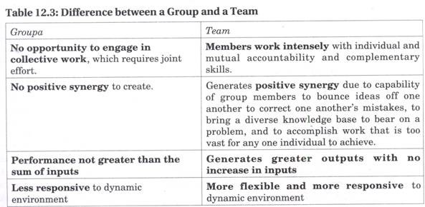](https://www.yourarticlelibrary.com/wp-content/uploads/2013/08/clip_image0107.jpg)**

Team-building helps to increase intra-group and inter-group effectiveness to bring members together, make them share their perception of each other and understand each other’s point of view.

Thus, resolve problems and work together in a cooperative and collaborative mode. Teams can be of four types – problem-solving teams (only making suggestion), self-managed, teams (operate without a manager), cross-functional teams (a group of experts from different specialities), and virtual team (members collaborate online). In terms of size, teams may be institutional (comprising of hundreds of members) and operational (a small, cooperative group, in regular contact and contributes responsibly to achieve task at hand).

**Eight Cs for Team Building:**

To show business results and profitability, ways are explored by the executives to improve their productivity.

**Successful team building, that creates effective, focused work teams, requires attention to each of the following:**

**1. Clear Expectations:**

The managers must clearly tell the team members of the expected performance and the team members must understand the reason for its creation. For it the organization must support the team with resources of people, time and money.

**2. Commitment:**

Team members must participate in the team, feel that the team mission is important, and show commitment to accomplishing the team mission and expected outcomes. Commitment will come if team members perceive their service as valuable to the organization and to their own careers.

**3. Competence:**

Team members must have the knowledge, skill and capabilities, the resources, strategies and support needed to accomplish its mission to address the issues for which the team was formed.

**4. Control:**

The team must have not only enough freedom and empowerment to feel the ownership necessary to accomplish its charter, but also the accountability. There has to be a defined review process.

**[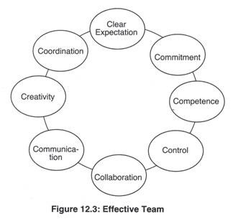](https://www.yourarticlelibrary.com/wp-content/uploads/2013/08/clip_image0123.jpg)**

**5. Collaboration:**

The team should understand group processes and work effectively and cooperatively with other members of the team. For it they have to understand the roles and responsibilities of team members, team leaders, and team recorders.

**6. Communication:**

To make team members clear about the priority of their tasks, and receive regular feedback, team members must clearly and honestly with each other. Diverse opinions be welcome and conflicts be taken up positively.

**7. Creativity:**

The team should value creative thinking, unique solutions, and new ideas; and reward members who take reasonable risks to make improvements. If necessary, it should provide the training, education, access to books and films, and field trips to stimulate new thinking.

The creative development of new products, new technologies, new services, or new organizational structures is possible because teams may have variety of skills needed for successful innovation.

Team members can uncover each other’s flaws and balance each other’s strengths and weaknesses. Managers should empower the team and make it accountable for the innovation process.

**8. Coordination:**

Teams should understand the concept of internal customer to whom they provide a product or a service. Team efforts need to be coordinated by a central leadership team that assists the groups to obtain what they need for success.

The cross- functional and multi-department teams must work together effectively. The organization should develop a customer-focused and process-focused orientation and move away from traditional departmental thinking.

Spend time and attention on each of these eight tips to ensure your work teams contribute most effectively to your business success. Your team members would love you, your business will see new heights, and empowered people will “own” and be responsible to their work processes

**Informal Group:**

In every organisation along with formal groups there exists informal groups which emerge naturally due to the response and common interests of the members who can easily identify with the goals or independent activities of the informal groups.

Sometimes the efforts may be driven by a common goal that may compliment or work against the goals of the formal group. An informal group can be defined as a group that evolves spontaneously, not shown in the organization’s structure, with the objective of fulfilling personal and social need of its members.

**Informal Group Vs Informal Organisation:**

An informal group is a voluntary group of people casually acquainted with each other for their own personal fulfillment because they have some common and shared backgrounds, characteristics and concerns (values / interests / hobbies / friendship).

Whilst it is easy to differentiate between a formal group and a formal organisation, the differences between informal group and informal organisation tend to be difficult. The difference between informal organization and informal group is that informal organisation is a larger entity consisting of all informal groups in an organization.

Informal Organisation= Sigma Informal Groups:

An informal group is the nucleus of informal organization. When an informal group adopts a formally defined structure and group processes, it no longer remains an informal group.

**Informal Group vs. Formal Group:**

The two are different in very many ways.

**[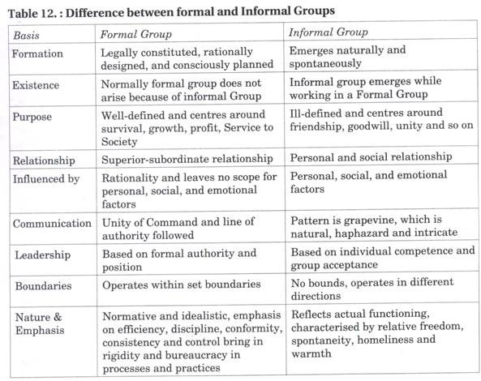](https://www.yourarticlelibrary.com/wp-content/uploads/2013/08/clip_image0142.jpg)**

**Characteristics of Informal Groups:**

**1. Creation:**

It is not created by the organisation but springs up spontaneously.

**2. Satisfaction of Needs:**

The needs which cannot be satisfied within the framework of formal organisation, like social and psychological needs of people, such people create informal groups.

**3. Voluntary Membership:**

Nobody is compelled to join an informal organization.

**4. Multi-Group Membership:**

A member of an informal group can be a member of more than one informal group to pursue different interests.

**5. Systems and Processes:**

Members of such groups follow their own norms, leadership, communication, etc. to remain cohesive. The communication channels are referred to as ‘Grapevine’. Grapevine i.e., informal channel runs very fast to spread the information across the organization.

**6. Leadership:**

Every informal group has a leader, selected by the group, and who is capable of helping to realize their goals. The moment it is realized that the leader is incapable, (s) he is replaced with a new leader.

**Reasons for the Emergence of Informal Groups:**

1. People working together may come together.

2. People with similar values, beliefs, attitudes, and interests often feel attraction to come together.

3. Need satisfaction – to belong, to associate, etc.

4. Removal of monotony of routine tasks – to get rid of monotony and psychological fatigue, job-related boredom and frustration provides an opportunity to behave in a natural and relaxed manner.

5. Promotion of other interests and pursuit of goals – People join Rotary or Lions Club to expand their contacts which may help them to satisfy their personal goals.

**Benefits of Informal Groups:**

**The benefits of an informal group are as follows:**

1. Blending with formal group allows people to work for the formal organisation.

2. Informal work group lightens the workload for the formal manager.

3. Brings satisfaction and stability to the organisation as a whole.

4. Provides a useful channel of communication.

5. Encourages managers to plan and act more carefully.

**Limitations of Informal Groups:**

**The limitations are as follows:**

1. Resistance to Change because they do not want to deviate from existing norms and learn new ways.

2. Informal group provides most fertile ground for Rumour Mongering because of maliciousness, lack of proper communication systems and processes and ambiguous circumstances.

3. Since a member of an informal group is also a member of a formal group, at times it creates role conflict.

4. Creativity of group member (s) is restricted because of strong pressure for conformity applied by the group.